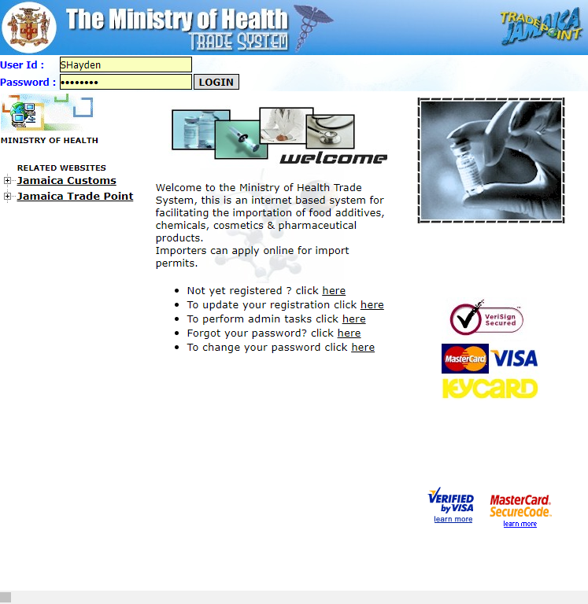
Figure 1 Shows Log-In Interface for Trade System

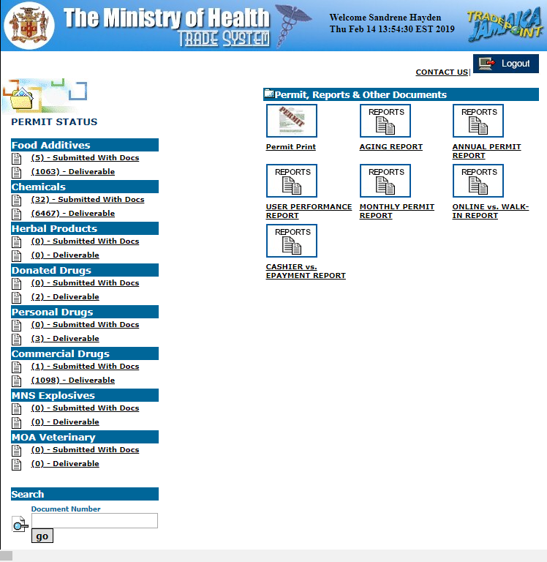
Figure 2 Shows Drug Inspector's Interface

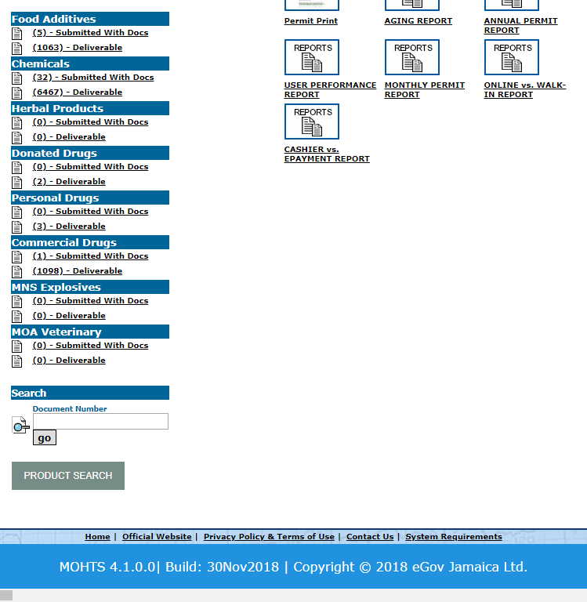
Figure 3 Shows the remainder of Drug Inspector's Interface

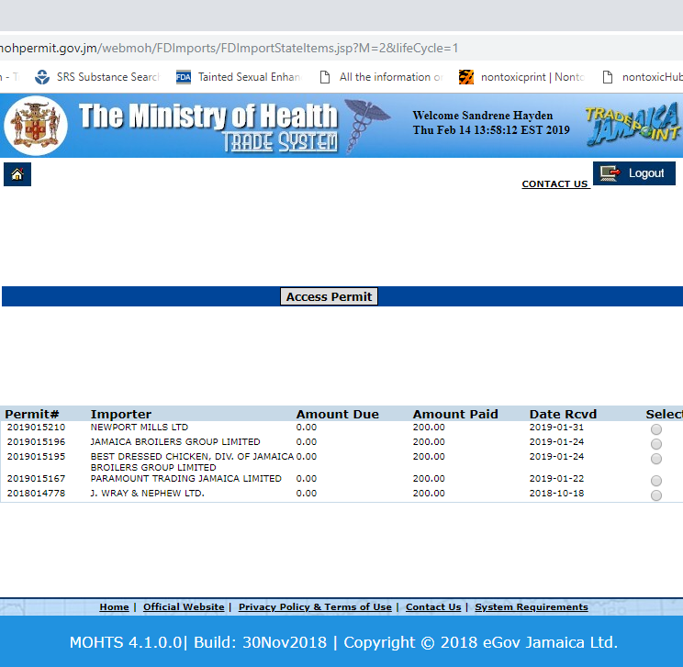
Figure 4 Interface after selecting Food Additives Submitted with Docs

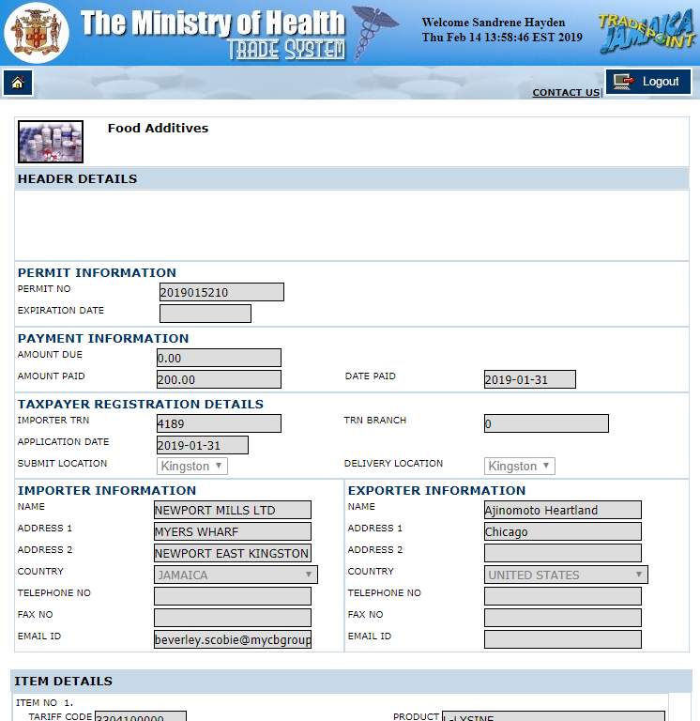
Figure 5 Shows application after selecting the first company
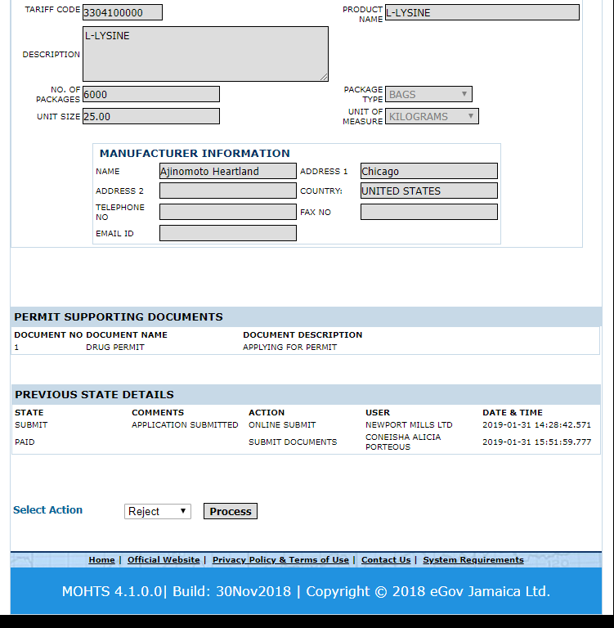
Figure 6 Shows remainder of application. Please note that while the select action default is Reject, there is also an Approval and Update option.

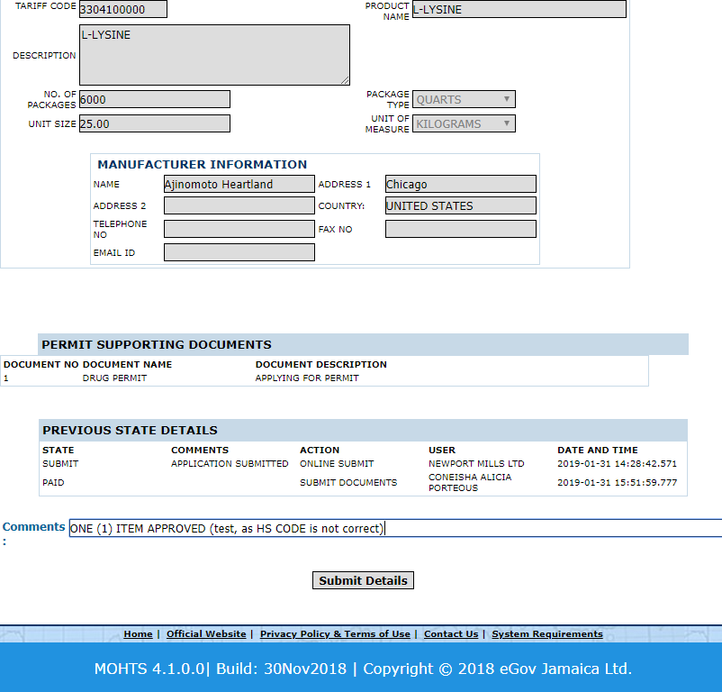
Once an application is approved, the interface returns to Figure 4 with the words ‘Permit Approved’ below access permit.
Figure 7 Shows interface after selecting an action
Once an application is rejected, the interface returns to Figure 4 with the words ‘Posted Successfully’ below access permit.
Once an application is updated, the interface returns to Figure 4 with the words ‘Permit Updated’ below access permit.

